***Weekly***

***progress***

***report***

*BY*

*G.yeshwanth*

*217Z1A6721*



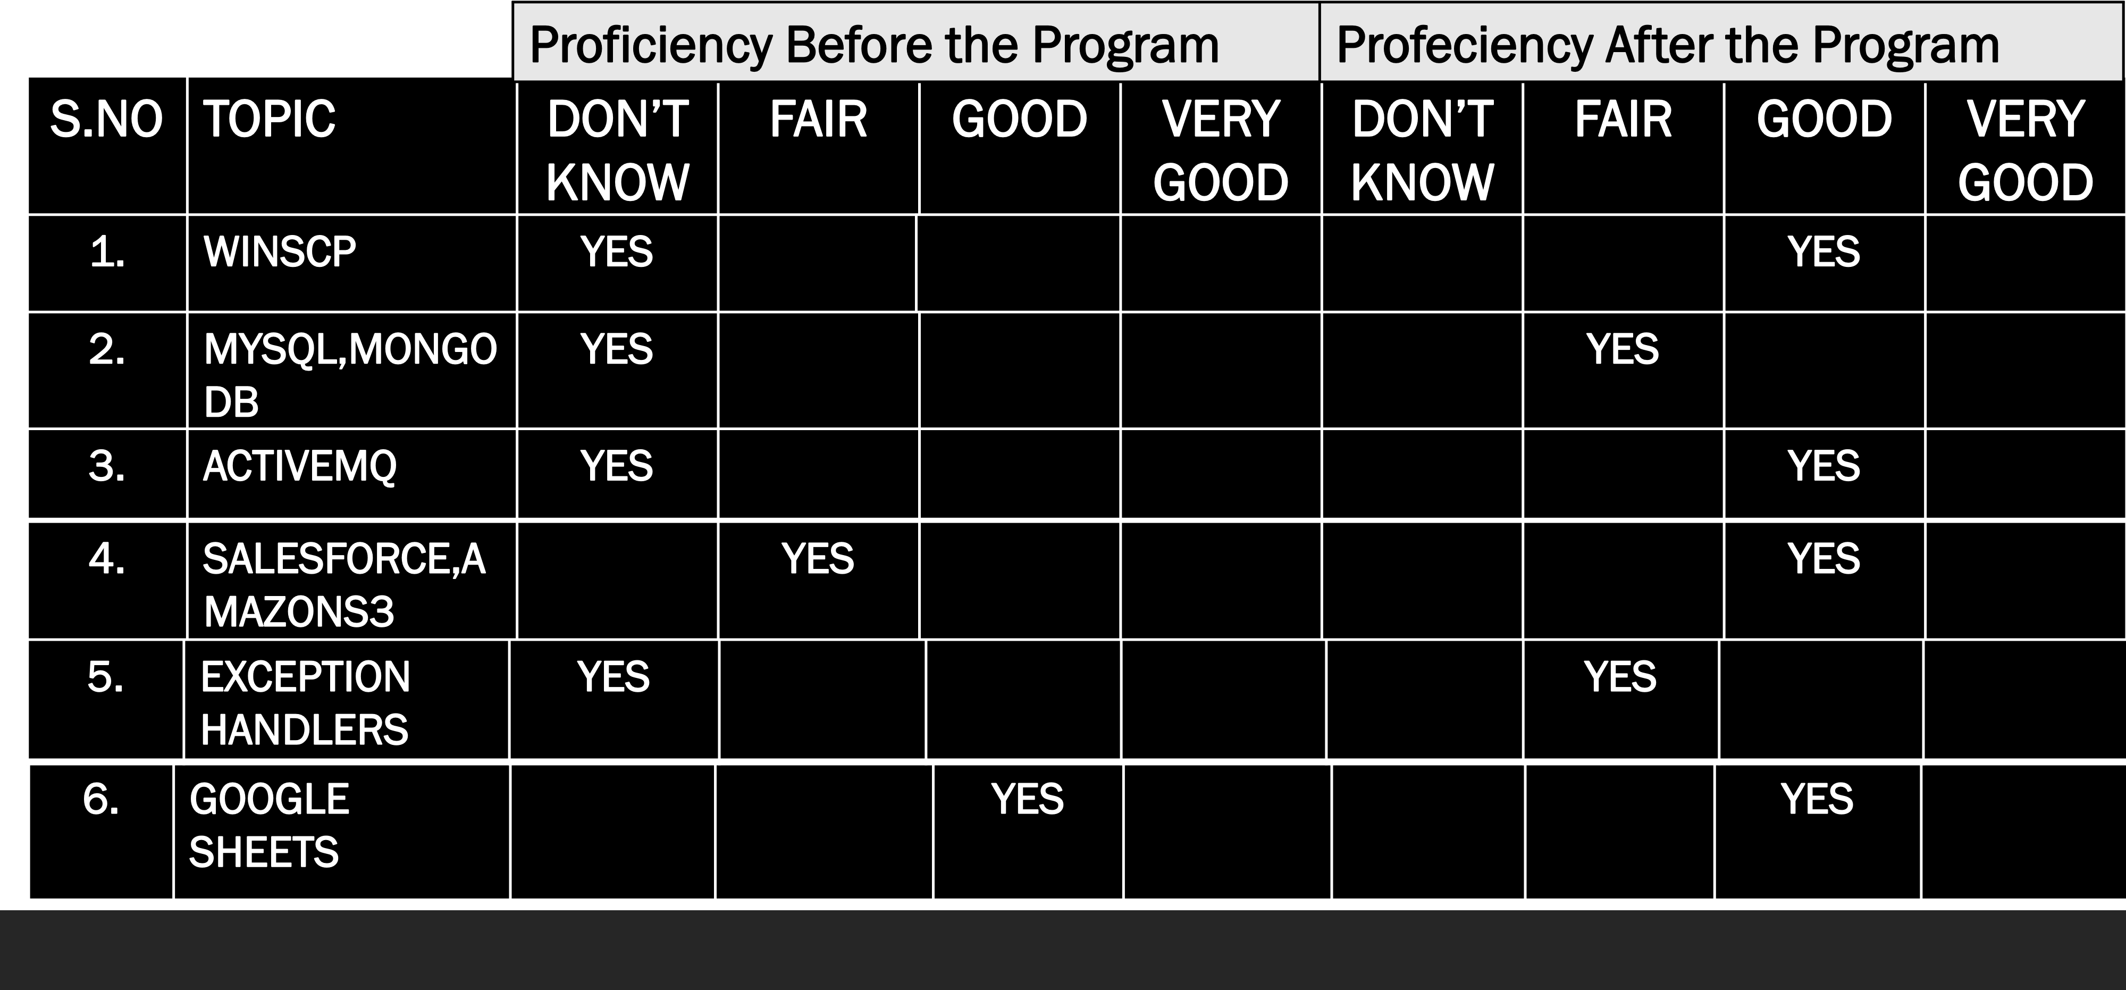*PROGRESS*

THANK YOU